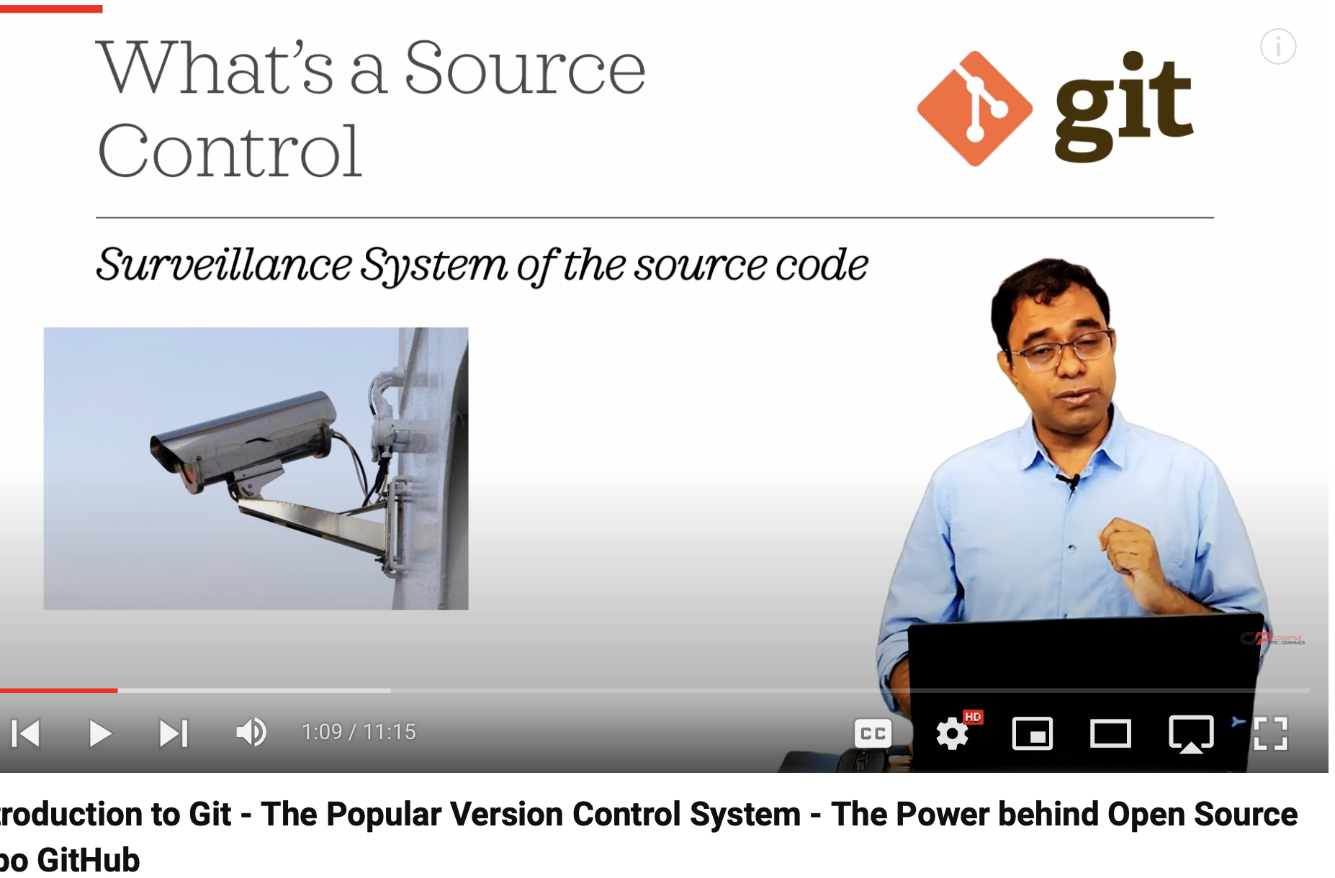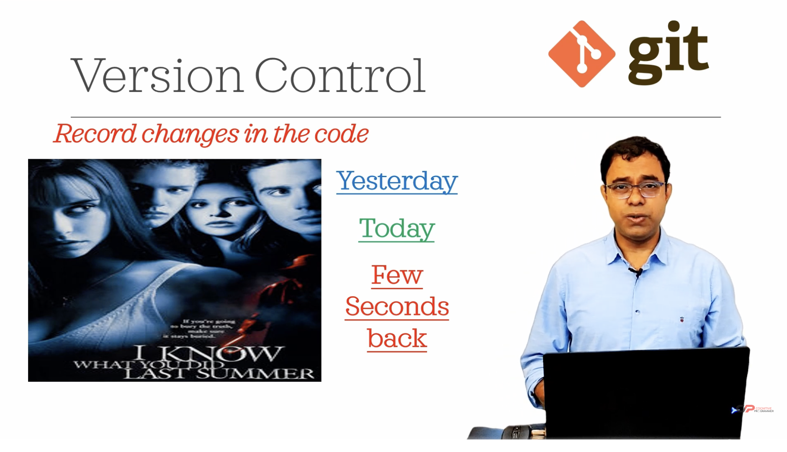

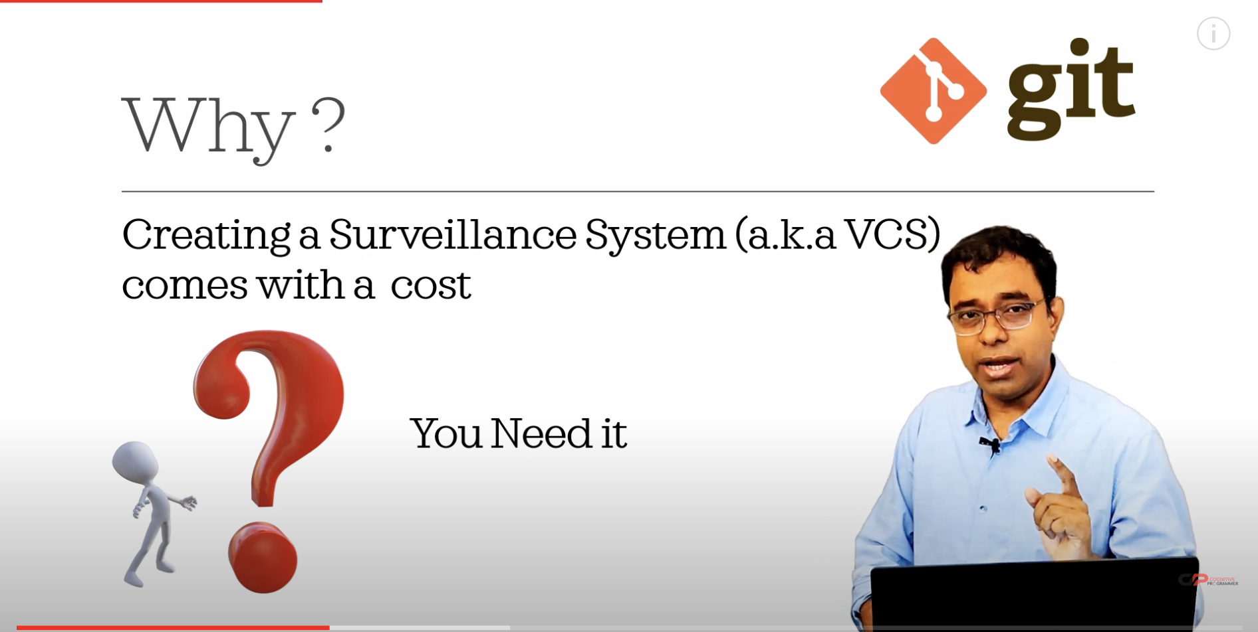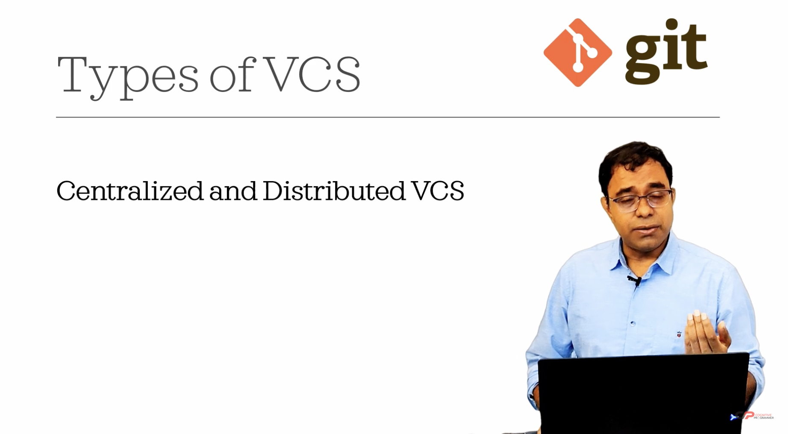

SVN is a centralized and git is a decentralized version control system.

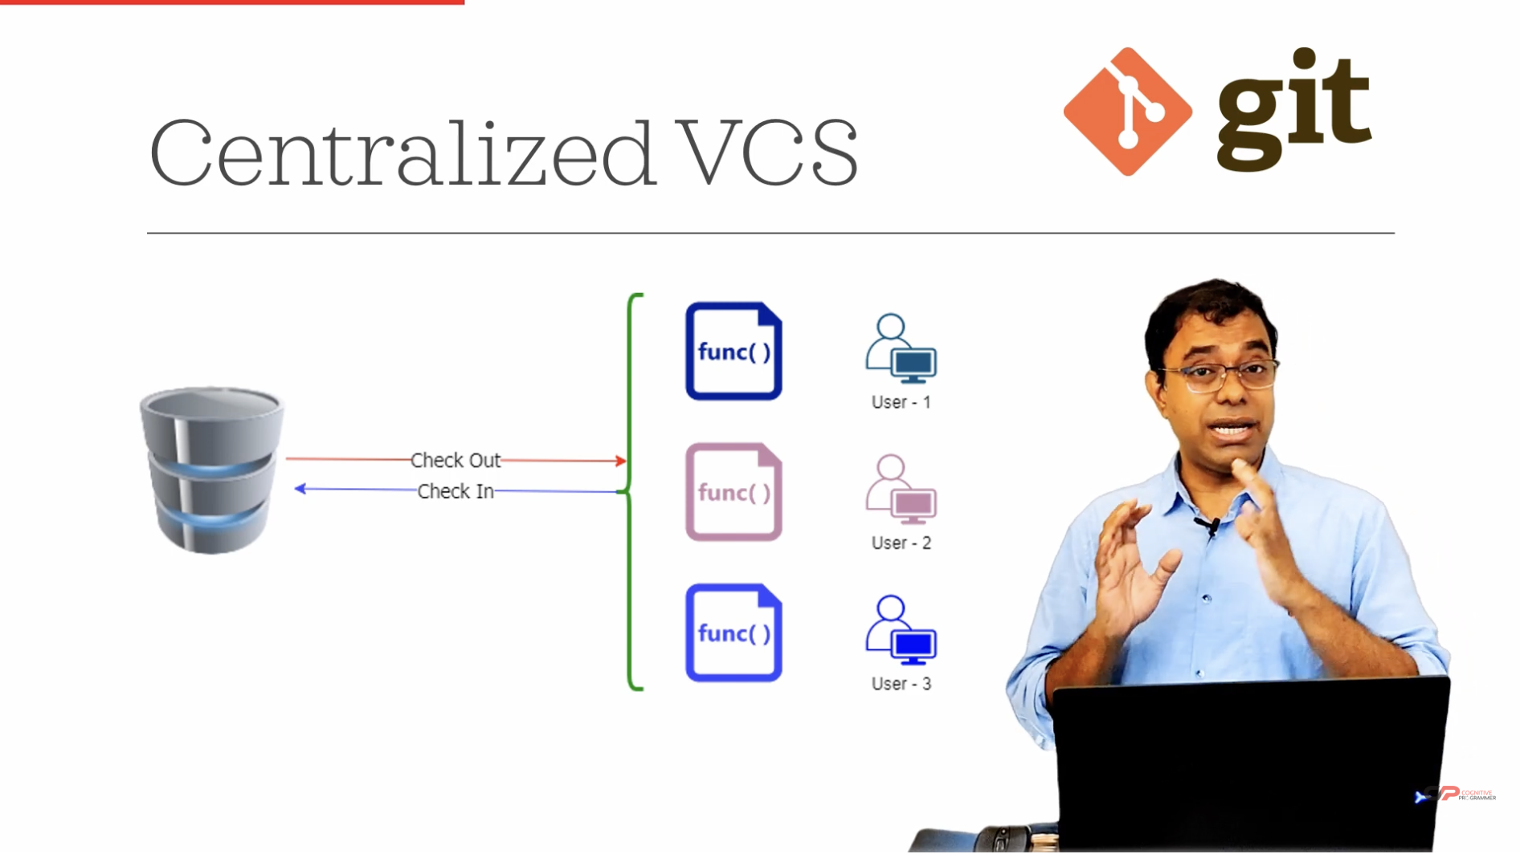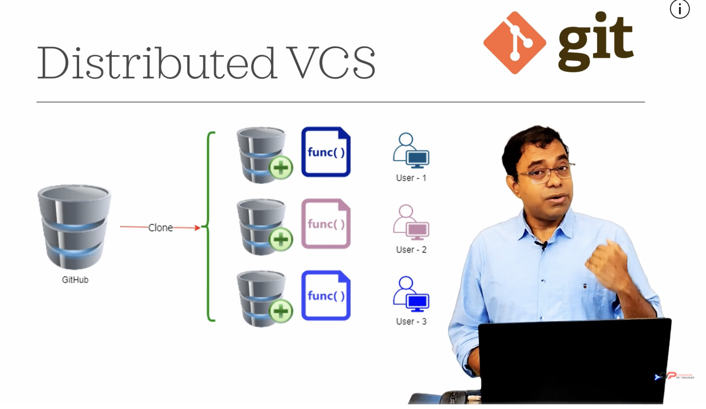

Your explanation captures the fundamental differences between Centralized Version Control Systems (CVCS) like SVN and Distributed Version Control Systems (DVCS) like Git. Here’s a brief overview to further clarify:

**Centralized Version Control Systems (CVCS)**

* **Server-Centric**: In CVCS, all version control activities are managed through a central server. The server holds the complete history and current state of the project.
* **Check Out/In**: Users check out files from the server to work on them and must check them back in to update the server. This often means that only one person can work on a file at a time.
* **Network Dependency**: Working with the version history requires a constant connection to the central server, as all the versioning information is stored there.

**Example**: Subversion (SVN)

**Distributed Version Control Systems (DVCS)**

* **Local Repositories**: In DVCS, every user has a full copy of the repository, including the entire history, on their local machine. This allows users to work offline.
* **Local Operations**: Users can commit changes, view history, and branch without needing a network connection because all operations are performed locally.
* **Synchronization**: Changes can be synchronized with other repositories (e.g., on GitHub) when a connection is available. This is typically done by pushing changes to or pulling changes from the remote repository.

**Example**: Git

**Key Differences**

* **Flexibility**: DVCS allows multiple people to work on the same files simultaneously without interfering with each other.
* **Offline Capabilities**: DVCS supports offline work because users have complete local repositories.
* **Collaboration**: DVCS enables easier collaboration through branching and merging, allowing multiple workflows and features to be developed simultaneously.

This model allows for a more decentralized workflow, where individual contributors can work independently and then merge changes into a shared central repository, facilitating collaboration and flexibility.

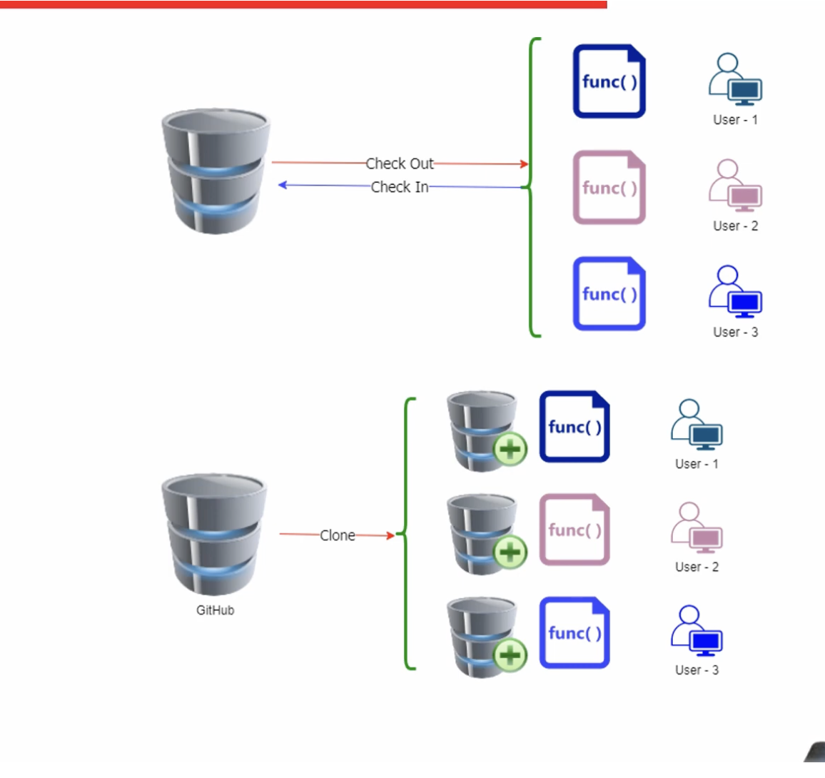So let's see side-by-side. The top one is centralized version control system. The bottom one is distributed version control system. You understand the difference. In centralized version control system, nothing comes in the user system and user cannot work on the file. Work means that you cannot check back your changes unless you are connected to the centralized version control system, which is not required in Git. Now we understood that Git is a distributed version control system.

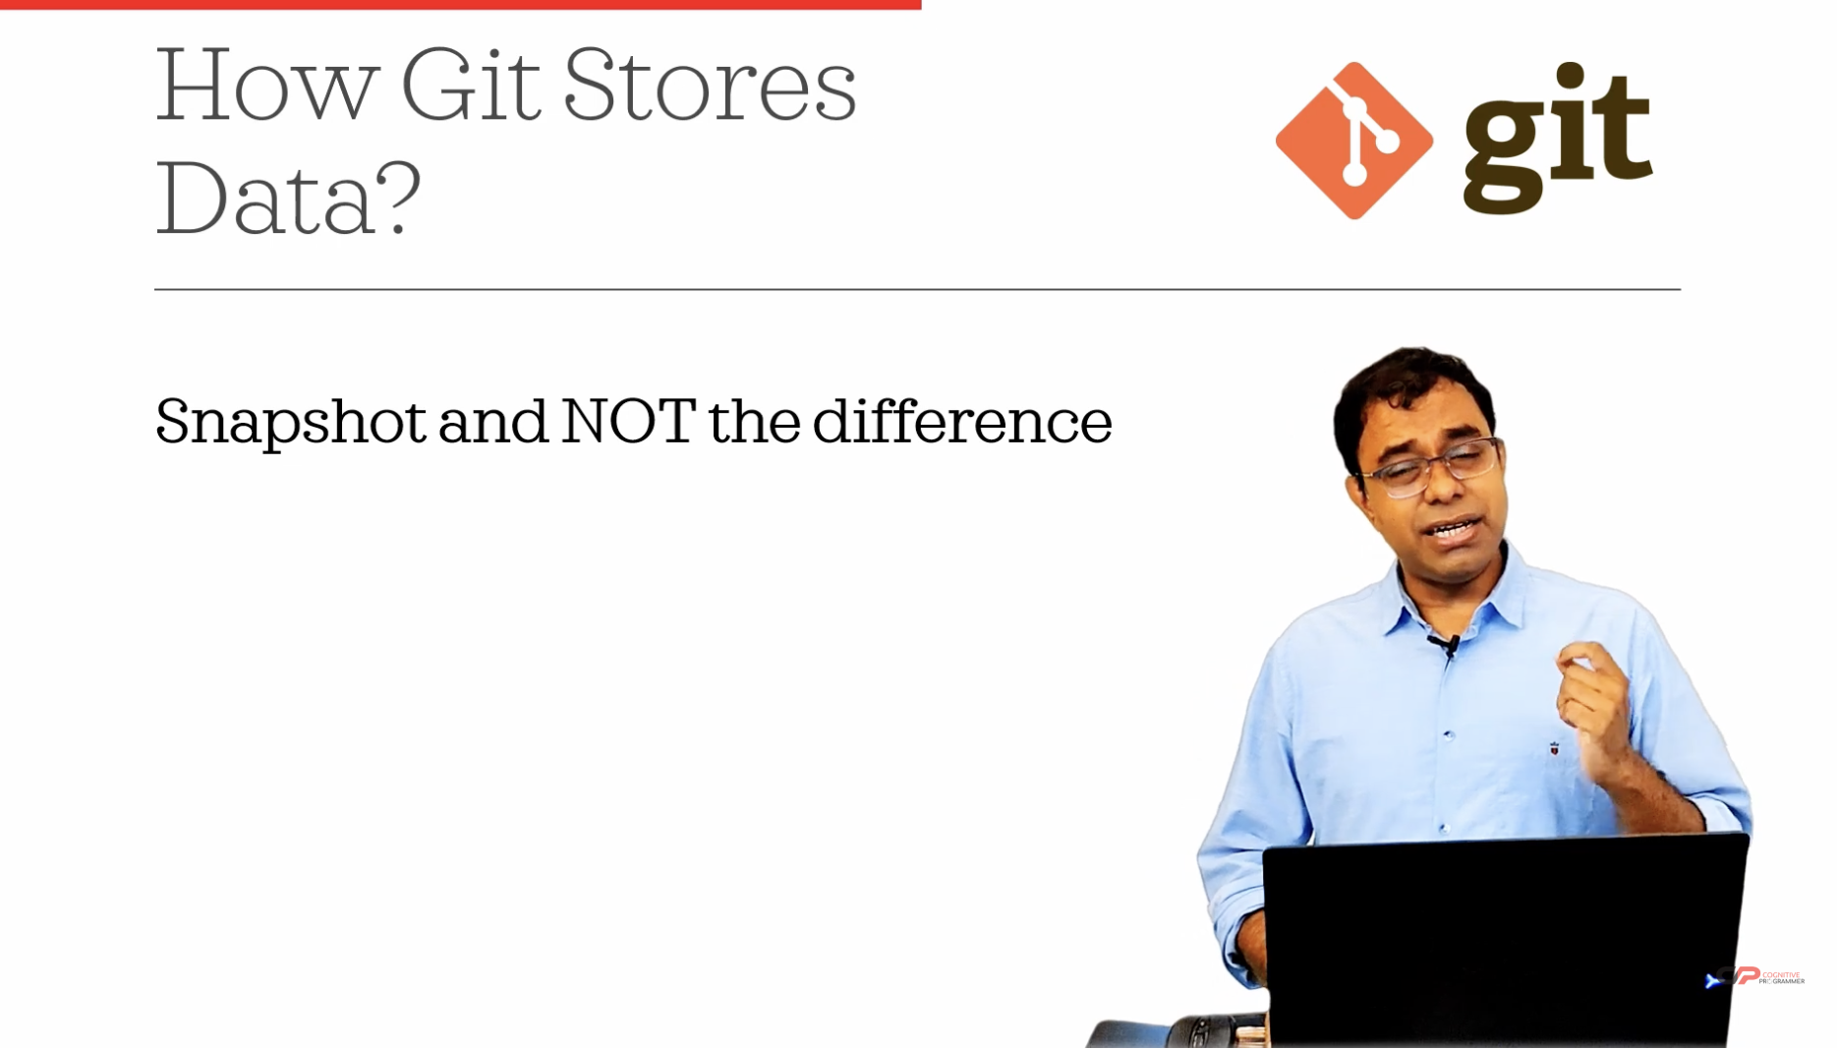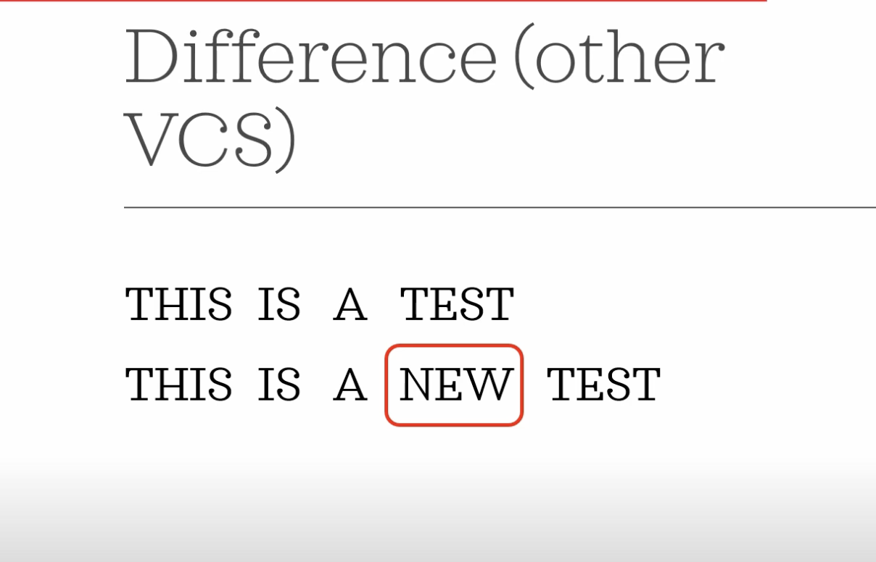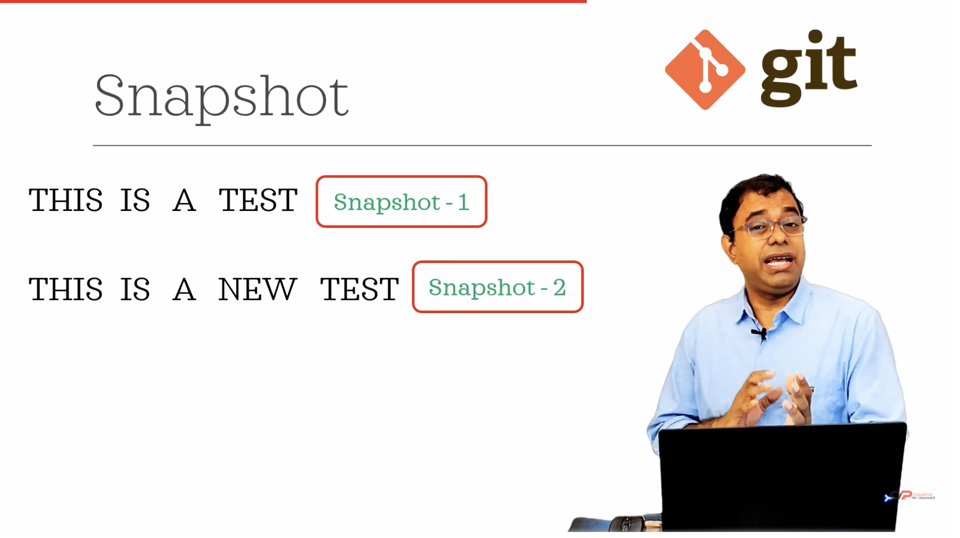

Your explanation highlights a fundamental aspect of how Git manages and stores data compared to other version control systems. Here's a breakdown of the key differences in data storage between Git and other version control systems:

**Traditional Version Control Systems**

* **Delta Storage**: Many traditional version control systems, like SVN, store the differences (or "deltas") between file versions. This means that they record changes made to files by comparing the new version to the previous one and storing only the changes.

**Example**:

* + **Original File**: "This is a test."
  + **Updated File**: "This is a new test."
  + **Stored Delta**: "new" (indicating the addition of the word "new").
* **Efficiency**: This approach can be efficient in terms of storage because only the changes (or deltas) are stored rather than the entire file, which can save space when changes are small.

**Git's Snapshot Storage**

* **Snapshot Storage**: Git takes a different approach by storing snapshots of the entire file system. Every time you commit changes, Git saves the state of your project as a complete snapshot.

**Example**:

* + **First Snapshot**: "This is a test."
  + **Second Snapshot**: "This is a new test."

Each commit in Git is a full snapshot of the file at that time.

* **Efficiency with Compression**: Despite storing complete snapshots, Git uses techniques like compression and deduplication to efficiently manage disk space. Identical files or file parts are stored only once.
* **Advantages**:
  + **Integrity**: Storing full snapshots ensures that the project can be accurately recreated at any commit point without relying on reconstructing files from a series of changes.
  + **Speed**: Operations like branching and merging are faster because Git deals with entire snapshots rather than piecing together changes.

**Summary**

The key distinction is that while traditional systems focus on storing the changes between file versions, Git captures the entire state of the project at each commit. This snapshot-based approach simplifies many version control tasks and enhances reliability and performance, particularly when working with complex histories or branching scenarios. This fundamental difference is why Git is often preferred for distributed development and large projects.

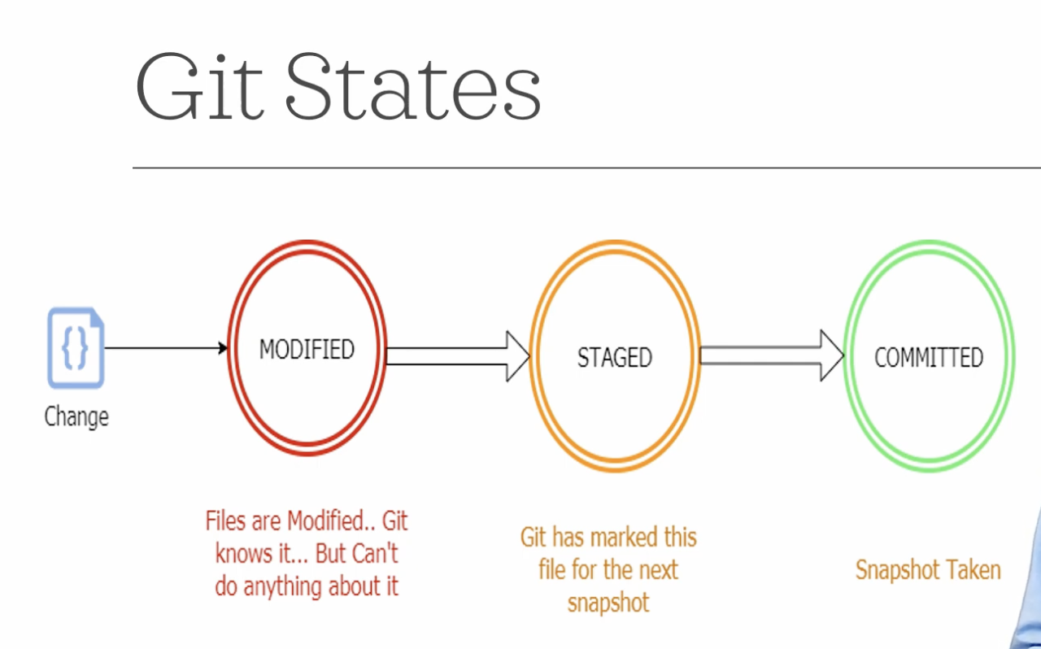

Your explanation of Git states is clear and captures the essential steps in tracking and managing changes within a Git repository. Here’s a breakdown of the three key states in Git:

**Git States**

1. **Modified**
   * **Description**: When you make changes to a file in your working directory (your local copy of the repository), Git recognizes that these files have been altered. At this point, the changes are in a "Modified" state.
   * **Significance**: Git is aware of the changes but hasn’t done anything with them yet. The modified state is essentially a local change that has not been staged or committed.
2. **Staged**
   * **Description**: To prepare your changes for a commit, you add them to the staging area using the git add command. This moves the changes from "Modified" to "Staged."
   * **Significance**: The staging area is a preparation zone where you can gather all the changes you want to include in your next commit. Staging allows you to selectively choose which modifications will be part of the commit, giving you control over what gets recorded in the repository’s history.
3. **Committed**
   * **Description**: Once your changes are staged, you can commit them to the repository with the git commitcommand. This creates a new snapshot of your current changes.
   * **Significance**: The "Committed" state represents a point in the repository’s history. This is a permanent snapshot of the changes, stored in the repository’s history, and can be reverted to or referenced in the future.

**Summary of Git Workflow**

* **Modify**: Make changes to files in your working directory.
* **Stage**: Add the changes you want to include in the next commit to the staging area using git add.
* **Commit**: Record the changes in the repository’s history with git commit, creating a snapshot of your project at that point in time.

Understanding these states is crucial for effectively using Git, as they provide a structured approach to managing changes, allowing you to control what gets saved in your project’s history and when. This workflow enables you to work on multiple features or fixes simultaneously without affecting the main project code until you are ready to commit them.

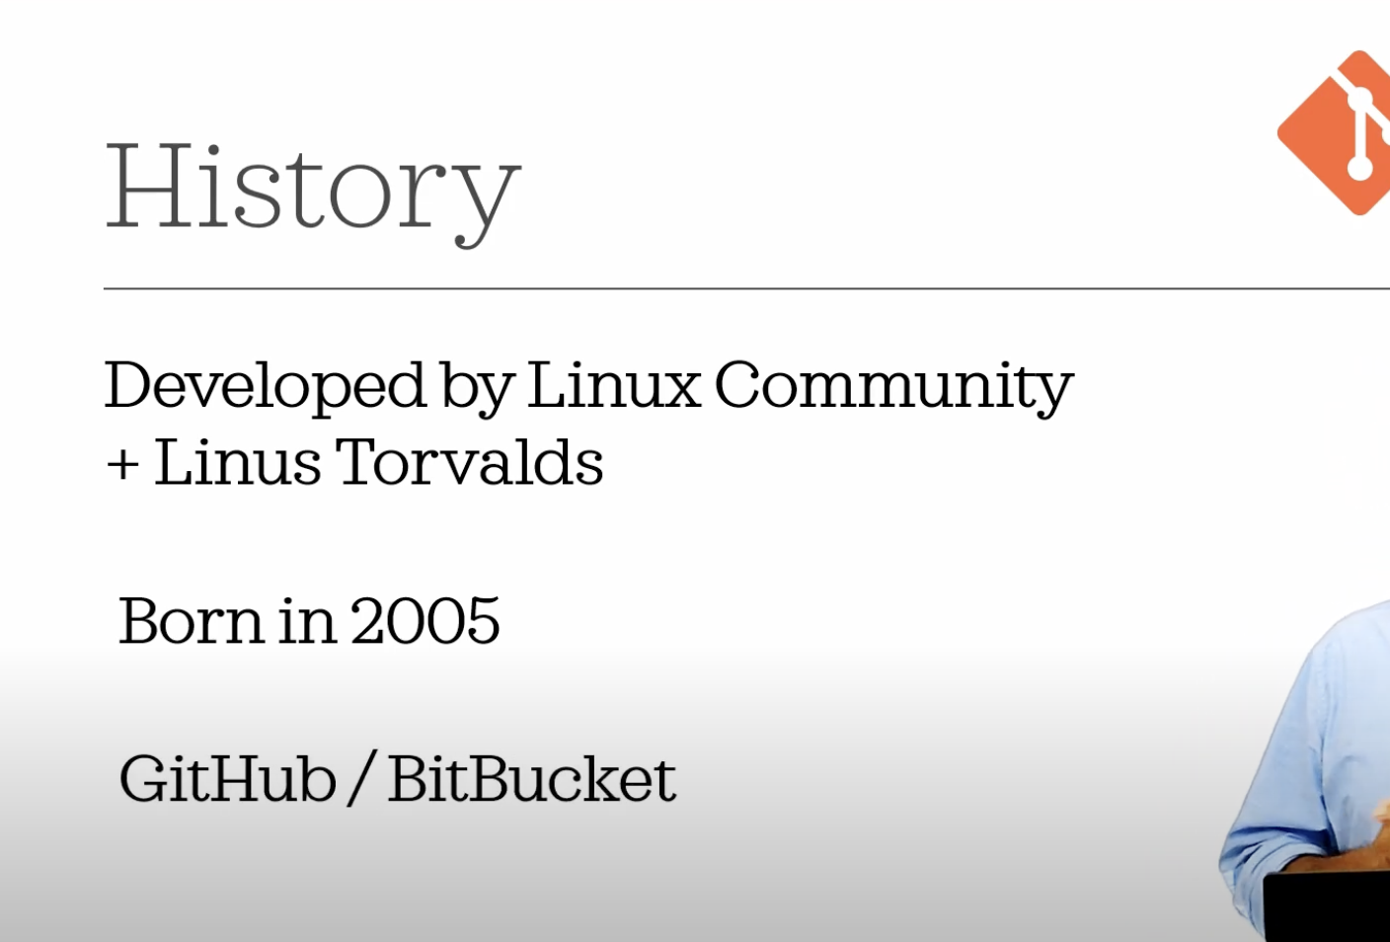

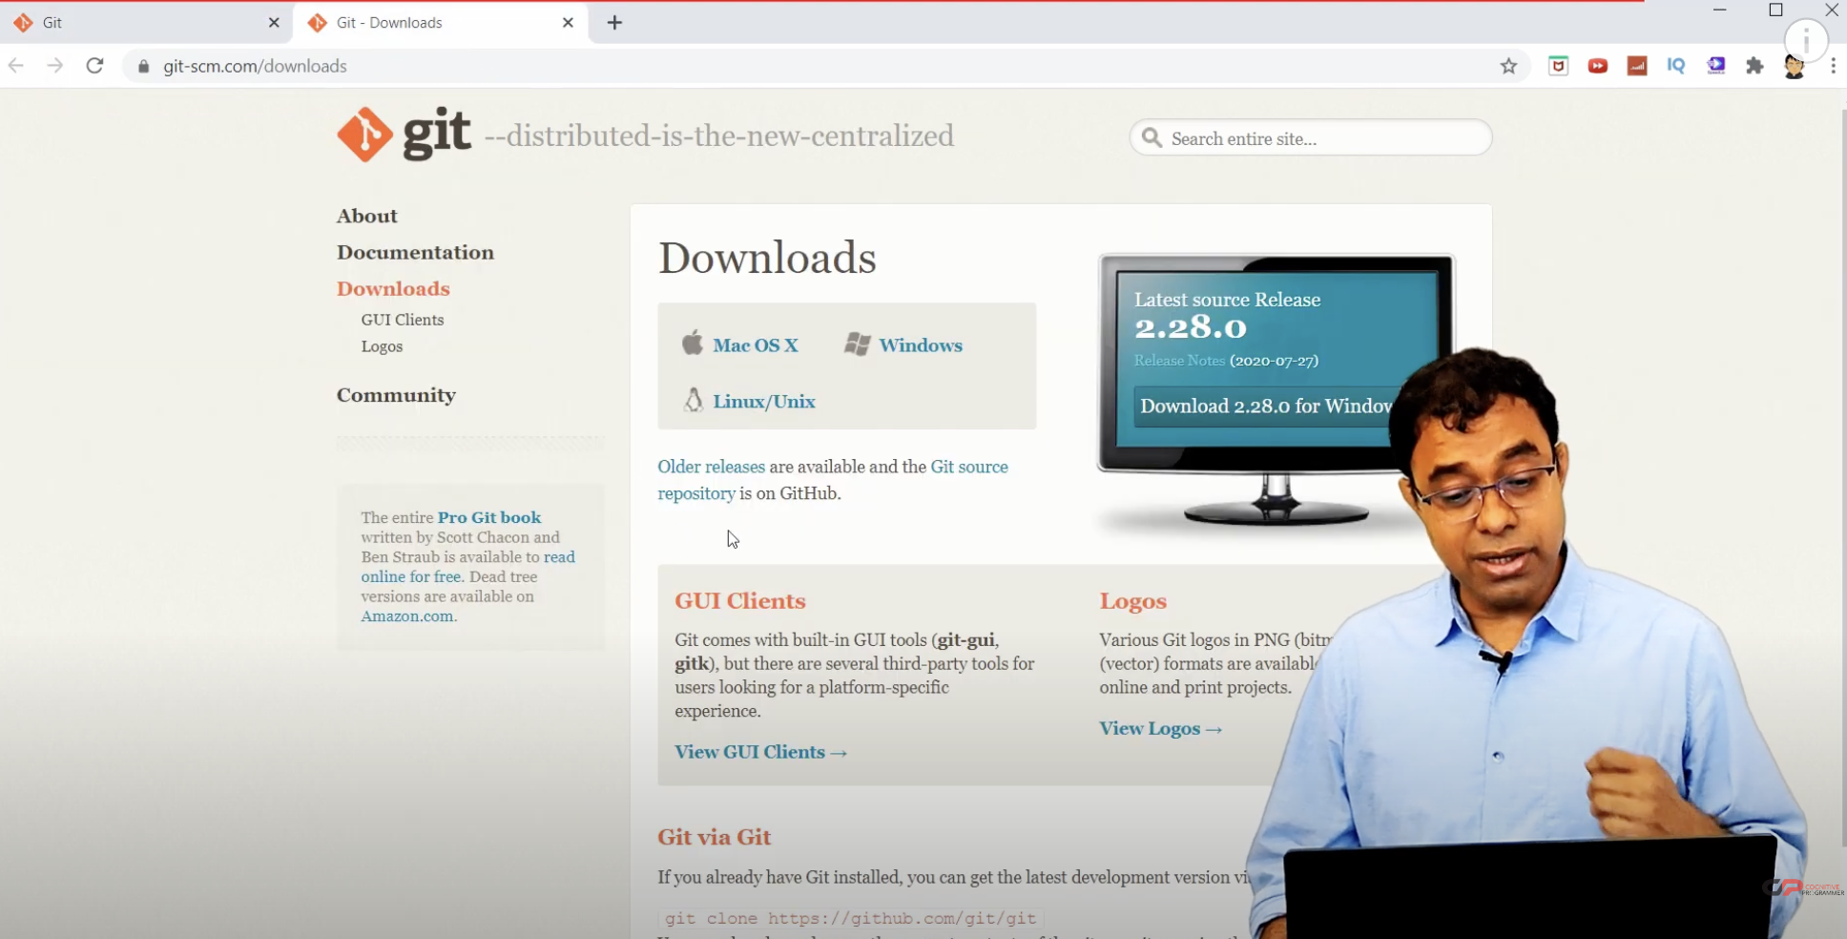

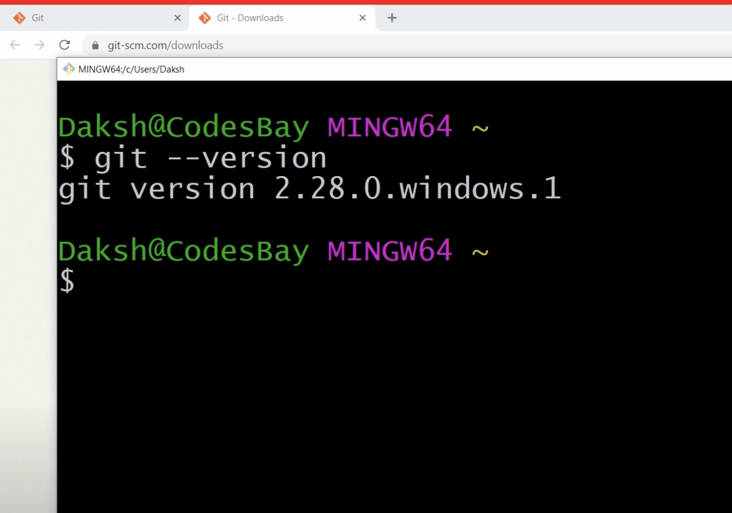

Here's a brief overview of Git's history and installation process, as well as some additional context to your explanation:

**History of Git**

* **Origin**: Git was developed by Linus Torvalds, the creator of Linux, in 2005. The Linux community needed a new version control system after their previous tool, BitKeeper, changed its licensing model, making it no longer freely available to them.
* **Motivation**: The need for a distributed, fast, and efficient version control system that supported non-linear development (branching and merging) drove the creation of Git.
* **Development**: Git was designed to be fast, scalable, and able to handle large projects with efficiency. It quickly became popular beyond the Linux community and is now widely used in software development.
* **Repositories**: Some popular platforms for hosting Git repositories include:
  + **GitHub**: A widely used platform for hosting open-source projects, offering collaboration features and community support.
  + **Bitbucket**: A similar platform by Atlassian, which supports Git and Mercurial repositories and integrates well with other Atlassian tools like Jira.

**Installing Git**

1. **Download Git**:
   * Visit the official Git website at [git-scm.com](https://git-scm.com/).
   * Navigate to the "Downloads" section to select the appropriate version for your operating system (Windows, Linux, or MacOS).
2. **Install Git**:
   * Follow the installation instructions specific to your operating system. The setup process may include configuring basic settings, such as your username and email, which Git uses for commit messages.
3. **Verify Installation**:
   * Open a terminal on Linux or MacOS, or Git Bash/Command Prompt on Windows.
   * Run the command git --version to check the installed version of Git. You should see output like git version 2.28.0 or a similar version number, indicating that Git is installed correctly.

**Getting Started with Git**

Once Git is installed, you can begin using it to manage your projects:

* **Initialize a Repository**: Create a new repository with git init.
* **Clone a Repository**: Copy an existing repository to your local system with git clone <repository-url>.
* **Commit Changes**: Stage your changes with git add, then commit them to the repository with git commit.
* **Push/Pull Changes**: Synchronize your local changes with a remote repository using git push and git pull.

This introduction provides a foundation for understanding what Git is, how it works, and how to set it up on your system. In your next steps, you can explore using Git in real-world scenarios, learning commands and workflows that will enhance your development process.